DR. AMBEDKAR COLLEGE, DEEKSHA BHOOMI, NAGPUR

Date: 28 March, 2022- 30 March, 2022
Name of the Programme: 3 Days workshop on “ADR, DRAFTING AND MOOTING SKILLS”
Name of the Speakers: Adv. Abhishek Mulmuley
Adv. Mohit Sharma
Adv. Richa Inamdar
Name of Program Co-ordinators: Mrs. Vaishali A. Sukhdeve
Ms Shilpa Rathod
Ms Sarika Kamdi
Number of Participants: 81
Name of Venue: Online Platform of Google Meet through Department of Law, Dr. Ambedkar College Deeksha Bhoomi, Nagpur

NOTICE
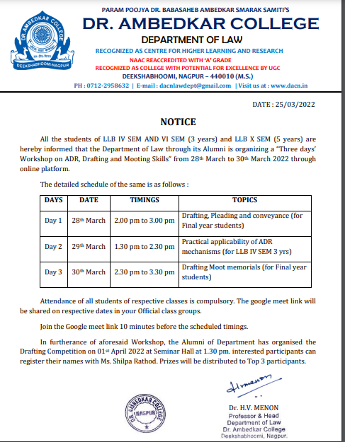
Report on Workshop on “ADR, DRAFTING AND MOOTING SKILLS”
28 March, 2022- 30 March, 2022
Department of Law of Dr. Ambedkar College, Deeksha Bhoomi had organised a three days’ workshop on “ADR, DRAFTING AND MOOTING SKILLS”. The course got overwhelming response from the final students of LLB 3 years and 5 Years course and IV Sem 3 years. The participants who have attended this workshop were near about 81.
The erudite resource persons invited to deliver lectures on different topics for this workshop are well experienced in the domain of practice. We have invited Adv. Abhishek Mulmuleye, Adv. Richa Inamdar and Adv. Mohit Sharma.
On the FIRST DAY the virtual inauguration was done by Adv Abhishek Mulmuley with Head of the Department Dr. Mrs. Hema Menon. This inaugural session was followed by the lecture delivered by Adv Abhishek Mulmuley. He has delivered the lecture on “Drafting, pleading and Conveyance” He enlightened the students on the basic rules of drafting and pleading and explained in details the fundamental principles of Drafting. He elaborately convenience the students on importance of drafting in the life of a lawyer. Further, he laid much emphasized on the part of Conveyance and its fundamentals. He has elaboratively explained the meaning and importance of Conveyance and its different modes. He shared all the specific format of all the different modes of conveyance along with the legislative provisions. Total 88 Students were present. The Program was conducted and concluded by Ms Shilpa Ram Rathod, Assistant Professor in the Department of Law of college.
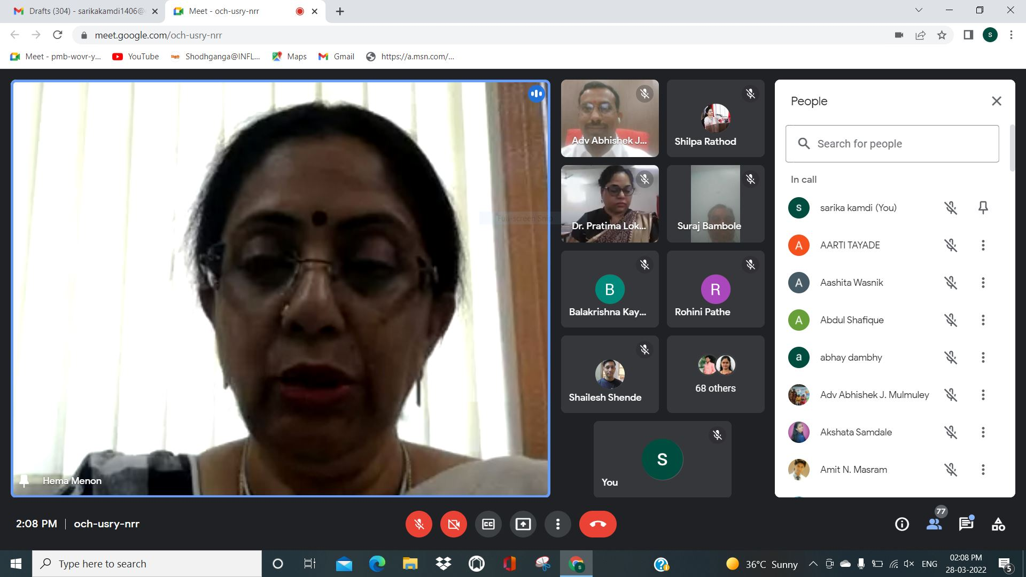
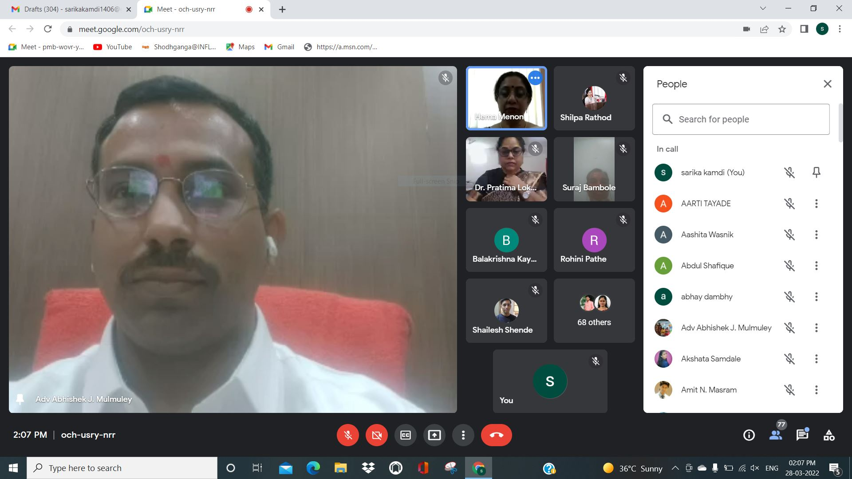
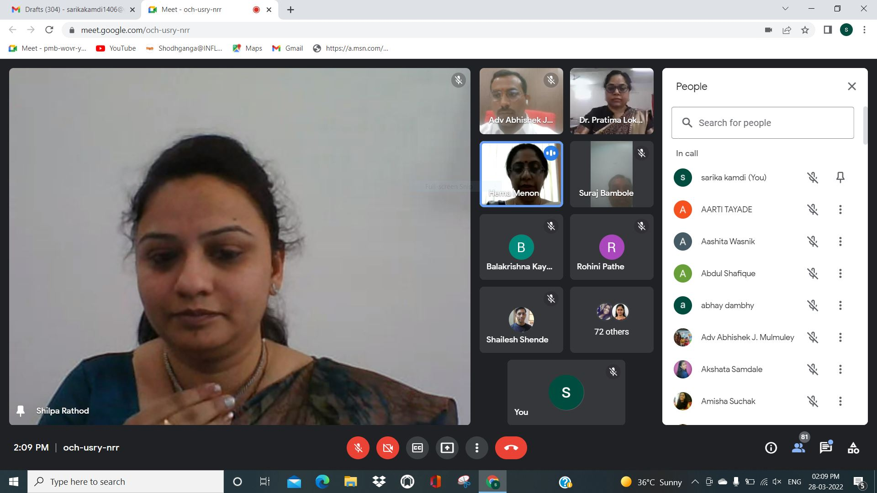

On the SECOND DAY the session has been organized on “Practical Applicability of ADR” for which Adv. Mohit Sharma invited as a resource person. He aptly discussed the importance of ADR mechanism in India and different types of alternate dispute resolution. He has further explained the different types of ADR available to the parties for the resolution of their dispute. He laid the emphasis on the Lok Adalat and explained how it act as an alternative to the present court system. He has shared many live cases which has been successfully settled in the Lok Adalat. He further discussed the role of the ADR mechanism in new consumer Protection Act. The lecture was followed by question answer session wherein in he has satisfactorily answered all the questions form the students end. The proceeding of this day has been conducted and concluded by Mrs. Vaishali Sukhdeve, Assistant Professor in the Department of Law of college.
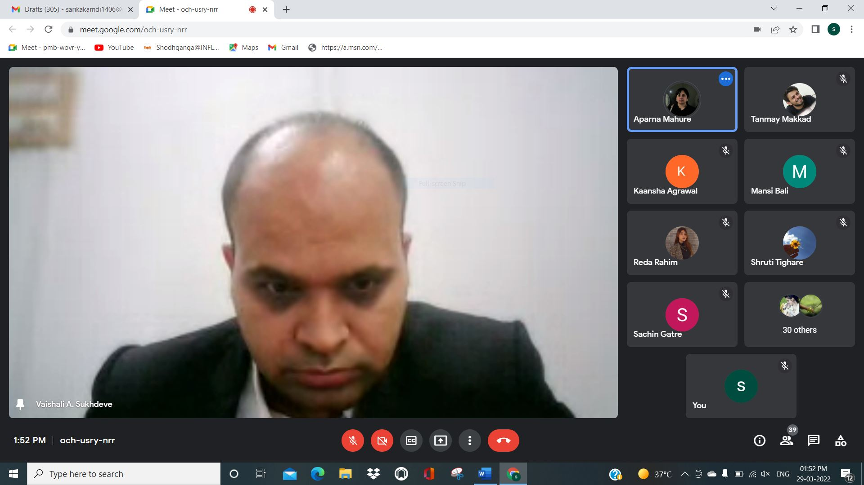
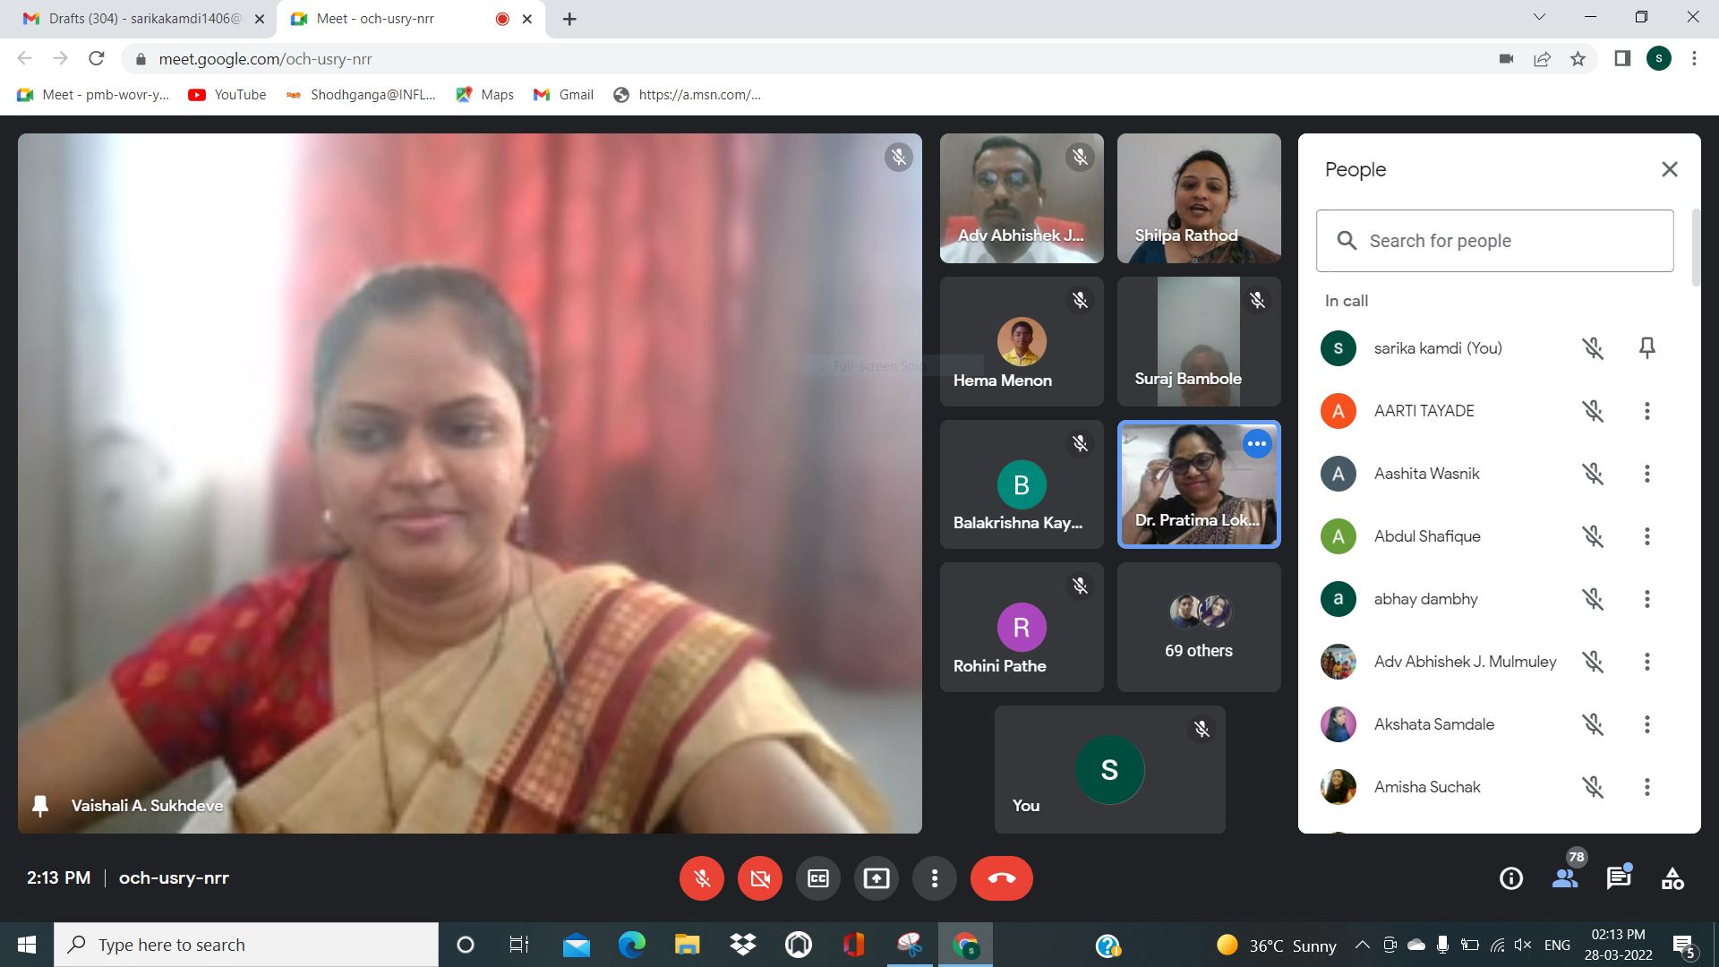
On the THIRD DAY the session has been organized on “Drafting Moot Memorials” for which Adv. Richa Inamdar invited as a resource person. She aptly discussed the basics of moot memorial drafting. She has explained how to identify legal issues involved in the case, how to conduct research for moot memorials. She has further discussed three moot problems and explained various contentions of the case which involves law points in details, how to read and decipher the moot problem for better presentation of the case. Discussed how to put forward the arguments and what has to be arguments. She has further explained few key points with the students like command on legal language, presentation style, humbleness and other ethical facts which are of great importance in the moots. The proceeding of this day has been conducted and concluded by Ms. Sarika Kamdi, Assistant Professor in the Department of Law of college.

